**Push Down Feature**

*a feature implementation specific to one particular class has settled high in the class hierarchy*

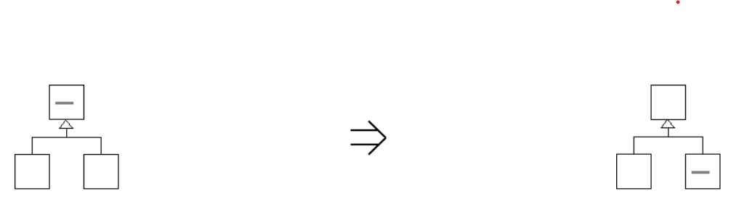

*push down the feature implementation to it's appropriate level of abstraction*

**Context:**

The [Push Down Feature](https://web.archive.org/web/20090914101043/http:/www.refactoring.be/thumbnails/rtn-pdf.html) thumbnail generalizes the refactorings where features are being pushed down the inheritance hierarchy. [Push Down Feature](https://web.archive.org/web/20090914101043/http:/www.refactoring.be/thumbnails/rtn-pdf.html) is the natural thing to do when part of a subclass its implementation has settled to high in the class hierarchy. Example refactorings are : *Push Down Method[Fowler]* and *Push Down Field[Fowler]*. Many times this thumbnail proves useful for testing purposes as Push Down Dependency.

See also : [Pull Up Feature](https://web.archive.org/web/20090914101043/http:/www.refactoring.be/thumbnails/rtn-puf.html)